

**Faculty of Engineering and Technology**

**Electrical & Computer Engineering Department**

**Control systems ENEE3302**

**Assignment**

**Prepared by:**

**Name:** mahmoud nobani **Id:**1180729

**Instructor**: Dr.jamal seyam

**Section**: 2

**Date:**6/8/2022

**Theory:**

Antenna Azimuth is a position control system that takes a position input (angle) transform it to voltage, amplifier it and use its value as an input to an actuator (motor), giving as a position output on the motor.

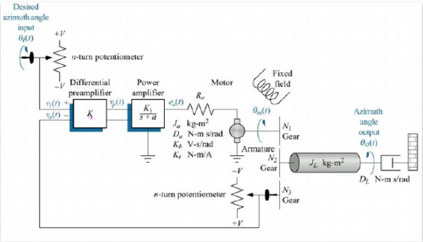

**Figure 1: Schematic diagram of antenna-azimuth position controlling system**

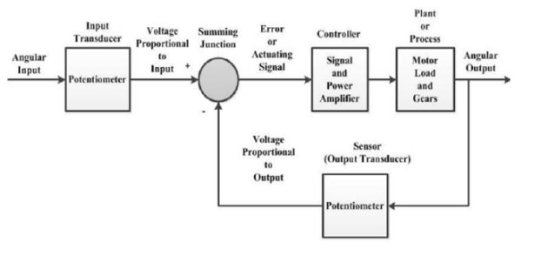

**Figure 2: Block diagram of antenna-azimuth position controlling system**

**Q1:** Use Matlab-Simulink to determine the transfer function of the system:

First, we used Simulink tool to make the block diagram of the system:

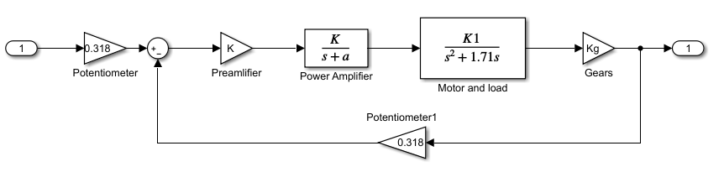

**Figure 3: block diagram**

We defined k as an initial value of 20, and using matlab with the following code:

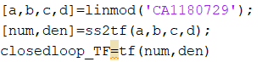

We get the following result for the transfer function:

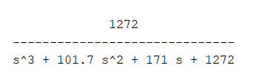

**Q2:** Determine the step response for five different values of K (including one instability conditions):

Using the following code:

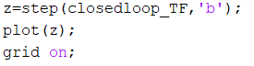

We were able to find the step response of the system, now we will try 5 different k values:

1. Default value k=20, system is stable:

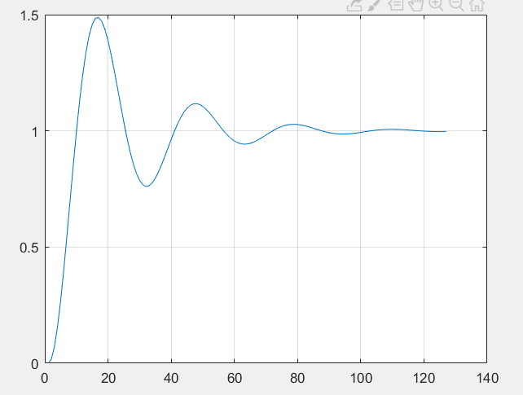

**Figure 4: step response, k = 20**

1. K=10, system is stable:

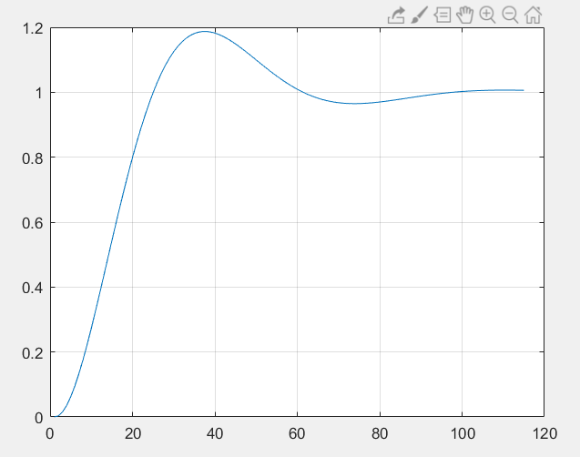

**Figure 5: step response, k=10**

1. K=50, system is stable:

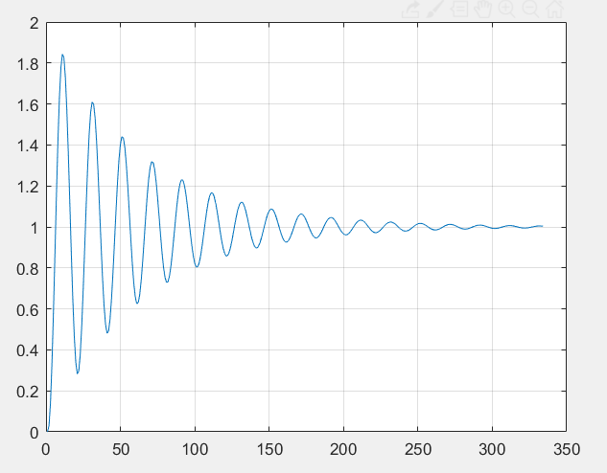

**Figure 6: step response, k=50**

1. K=60, system is stable:

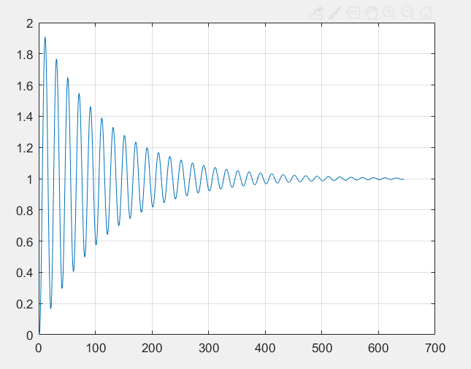

**Figure 7: step response, k=60**

1. K=100, system is unstable:

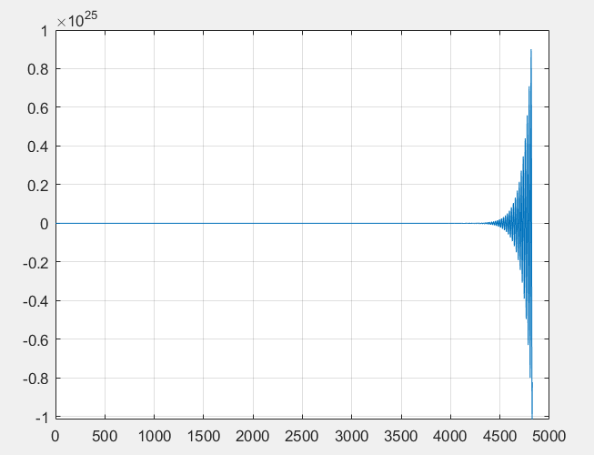

**Figure 8: step response k=100**

**Q3:** Determine the rising time, steady state time, over shoot, and steady state error under the stability conditions from the previous question.

Now we need to find the properties of the step response, to do that we use the following code (note that k = 20):



And we got the following results:

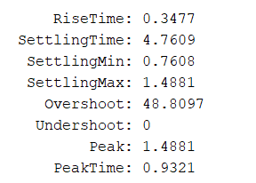

Now for the steady state error, I used the following code to find the position/ velocity and acceleration:

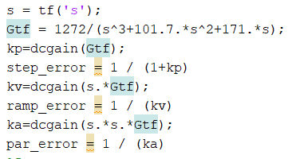

The results I got were as follow:

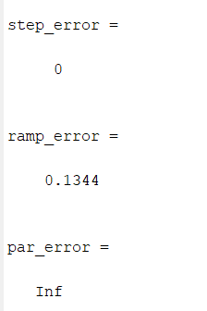

Thus, the system is type1, as seen in the transfer function.

**Q4:** Compute the stability region and verify your response by determining the step response for selected values in the different ranges:

for this part we need to find the region by hand and then verify it using MATLAB, the result:

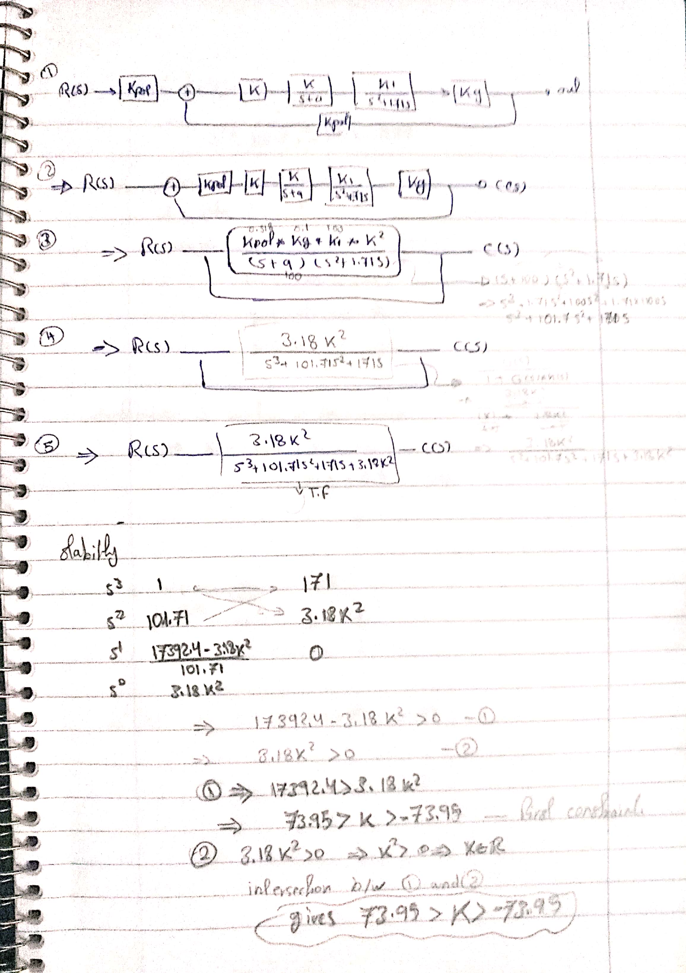

And the region of stability for k is [73.95, -73.95], to verify it, lets try 4 different k values:

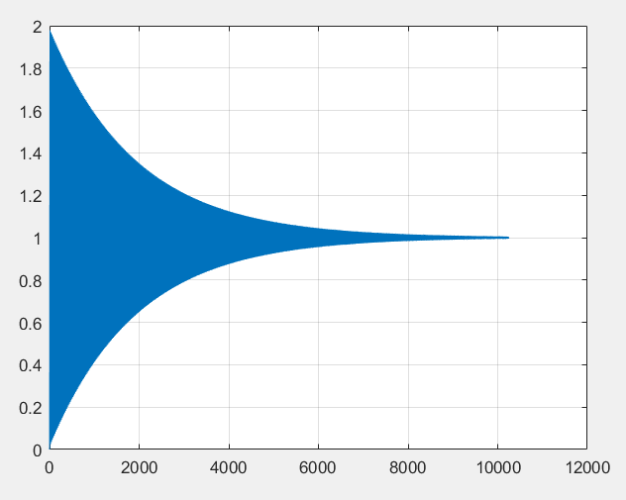

**Figure 9: step response, k=73, stable**

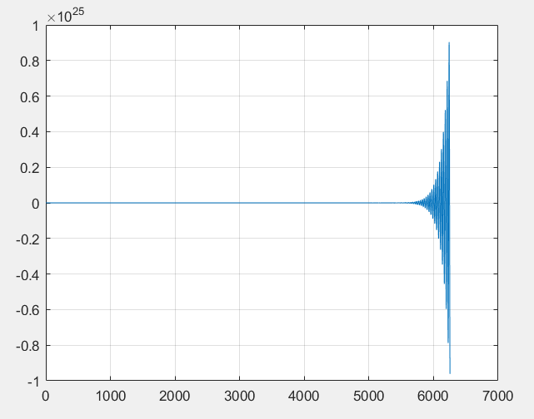

**Figure 10: step response, k=74, unstable**

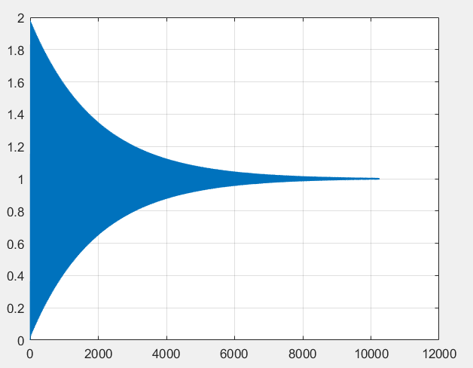

**Figure 11: step response, k=-73, stable**

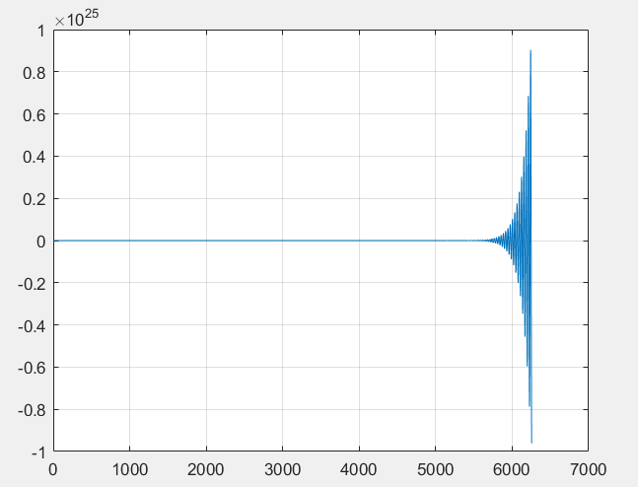

**Figure 12: step response, k=-74, unstable**

**Q5:** Determine a state space representation of the system and verify the order of the state space.

Using the following code:



note that k = 20, and we got the following results:

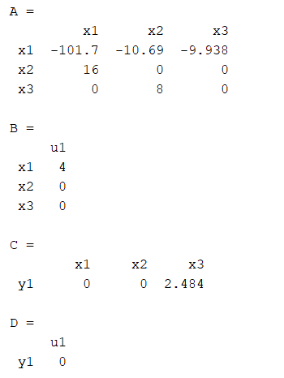

**Q6:** Convert your state space representation into external representation:

To do this, we just need the transfer function, we already did that in part 1, for further elaboration, I solved it on paper as shown below:

Note that there is a slight error because of rounding.

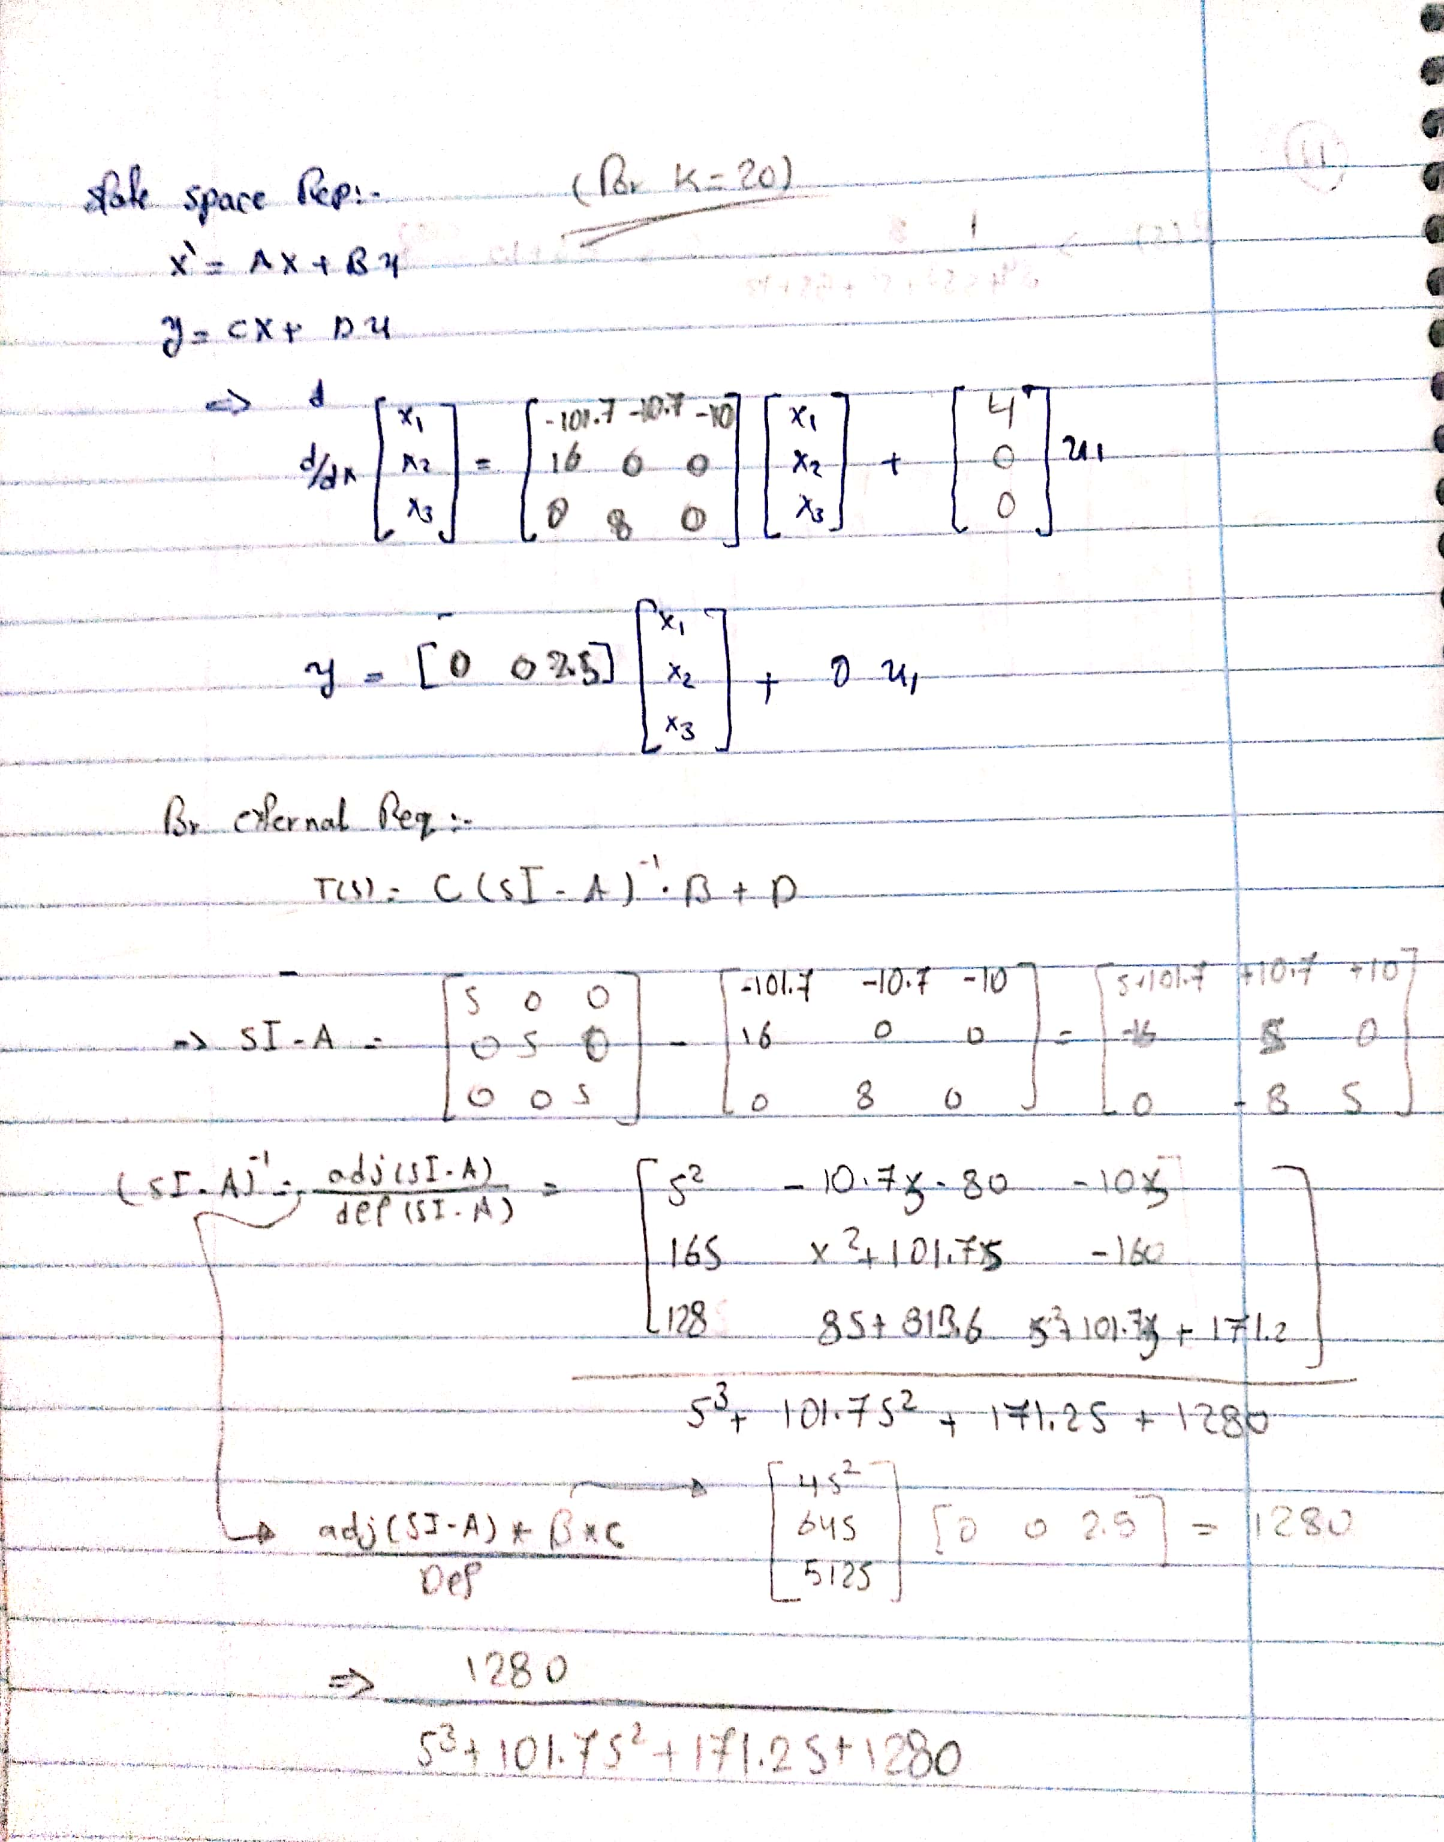

**Q7:** Plot the root locus of the system:

Using the following command:



I was able to plot the root locus as shown in the figure below:

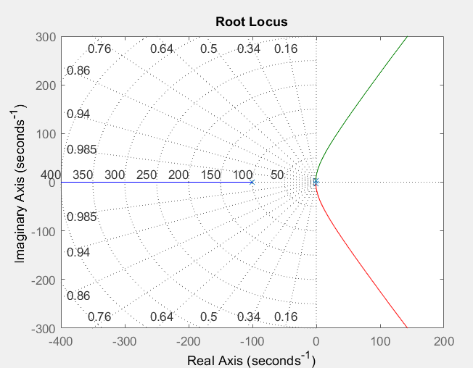

**Figure 13: root locus.**